Eight Discipline Report (8D Report)
To: DELL | 8D report No.:20230824
From:：Chicony Power Technology | RMA claim No.: N/A
CC： | Chicony Power P/N: A360AP01P
CC： | Customer P/N: NN34T
Submit date: 2023/08/24 | Product description: SFF Kure E5 360W
Receive date: 2023/08/24
Subject：DC Cable LED brightness is dark
D1.) 問題解決成員:Use Team Approach
主持者 (Team Leader)：Wison_Li
內部成員 (Internal Team Members):
ME : Wison_Li
外部成員 (External Team Member):
Vendor : Linetek
D2.)問題說明:Problem Description:
(Note: Use who, what, when, where, why, how, how many to specify the Customer’s problem.)
試產185PCS,有4PCS LED燈偏暗,如下圖片所示:
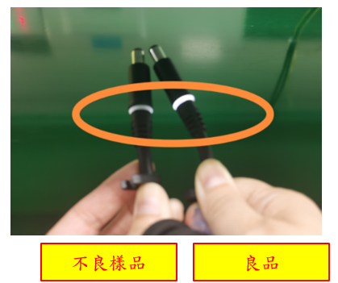
D3.)內部或客戶的暫時解決辦法及實施日期:Implement and Verify Containment Action:
(Note: Internal / external containment action effectiveness and date.)
內部出貨前sorting全檢,確認LED燈是否有偏暗.
D4.)不良原因確認: Define and Verify Root Causes:
(Note: Identify and verify all suspect causes, which needs explain why the problem occurred.)
拆解不良品確認，分析造成此不良原因为：由於燈罩是組裝式燈罩+芯線較粗（12AWG)，焊接半成品會彎曲，在成型內模時（合模過程中），會將燈罩后蓋拉開，并產生Gap.
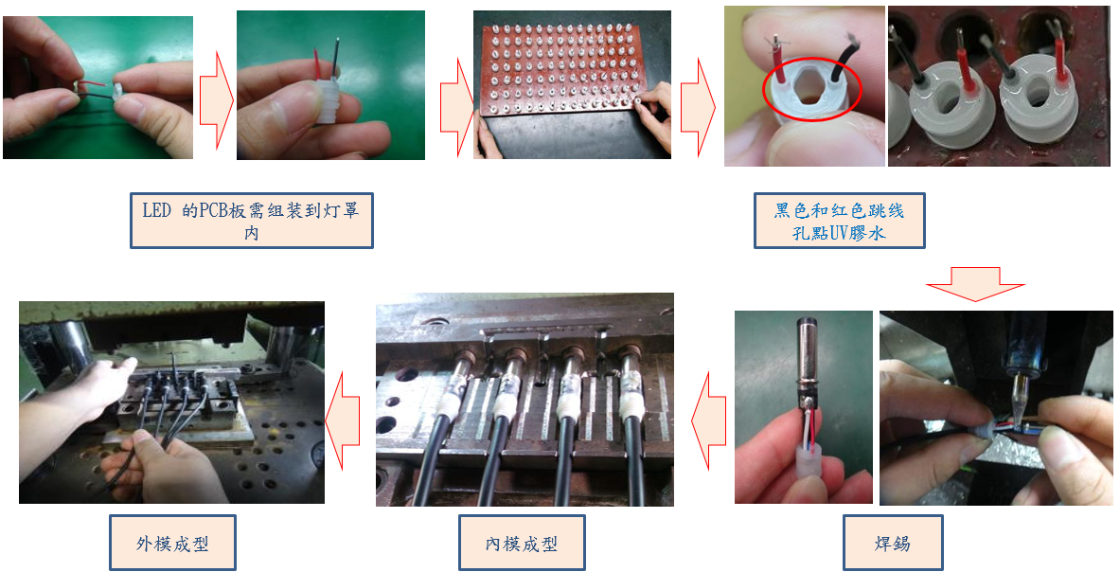
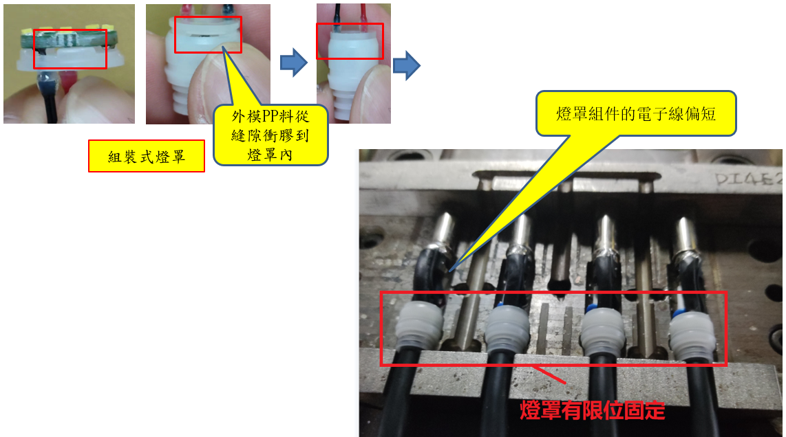
D5.)改善措施:Corrective Action Verification:
(Note: Be make sure the corrective actions is effective in process as well as able to fix the customer complaint problem)
短期對策:
針對外模PP料從縫隙衝膠到燈罩內，在燈罩組裝時除了黑色和红色跳线孔點UV膠水之外，增加燈罩組裝縫隙處繞燈罩點一圈快干膠，將燈罩固定住
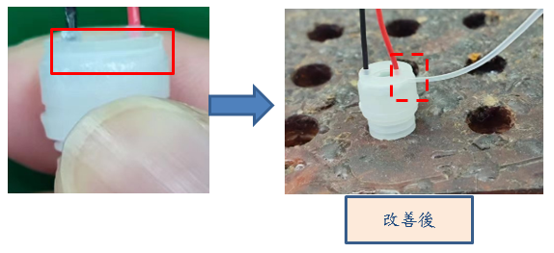
長期對策:
將燈罩組件的電子線長度加長1~2mm，不會因為太短而使燈罩後蓋被拉開。
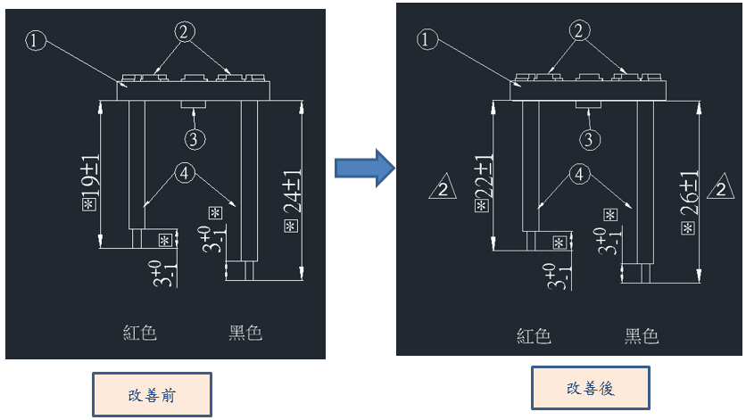

D6.)改善措施實施日期:Implement Permanent Corrective Actions:
(Note: Be provide the phase-in date or lot# of corrective actions implementation in process)
immediately
D7.)預防再發生措施:Prevent Recurrence:
(Note: Modified the management, operating systems, practices, and procedures to prevent recurrence for the problems as well as lessons learned cases.)
Same as D5
D8.)確認並感謝問題解決成員:Check and Congratulate the Team:
(Note: Recognize the collective efforts of the team.)
Thanks to you all！！！
ME:Wison_Li ; Vendor : Linetek

